Lab 05: Internet as a System
Team Members: Myles Sartor

Activity Instructions
The instructions can be found in the Assignment in Canvas.

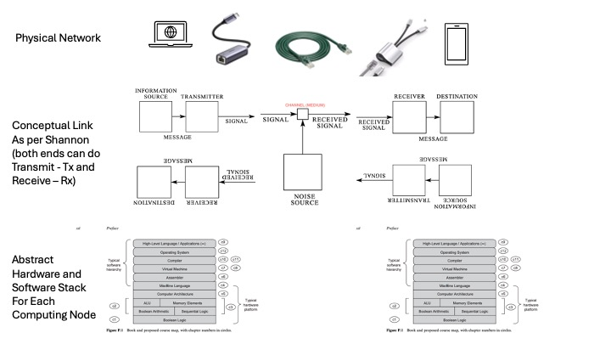
Figure 1: Conceptual Model of Lab Network

Questions For Reporting Back
Fill in these questions with the responses that you came up with as a team or that we discussed as a class.
- Physically build a LAN (Local Area Network) at Layer 1 and Layer 2 (insert the photos you capture)
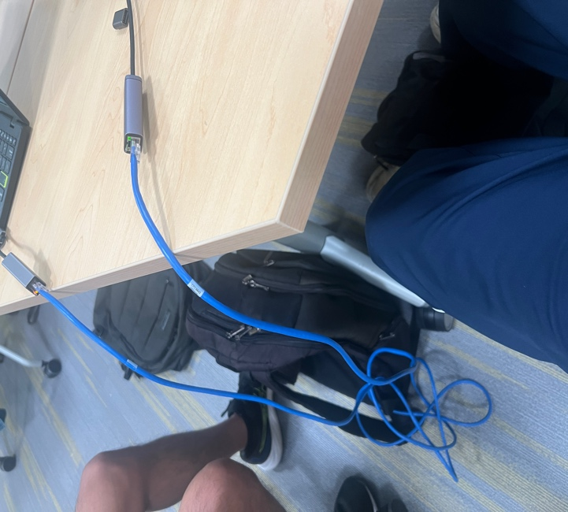

- Setting Up a Successful Connection with the Addition of Layer 3 (insert the photos you captured)
My IP address (Configured with Subnet and router):
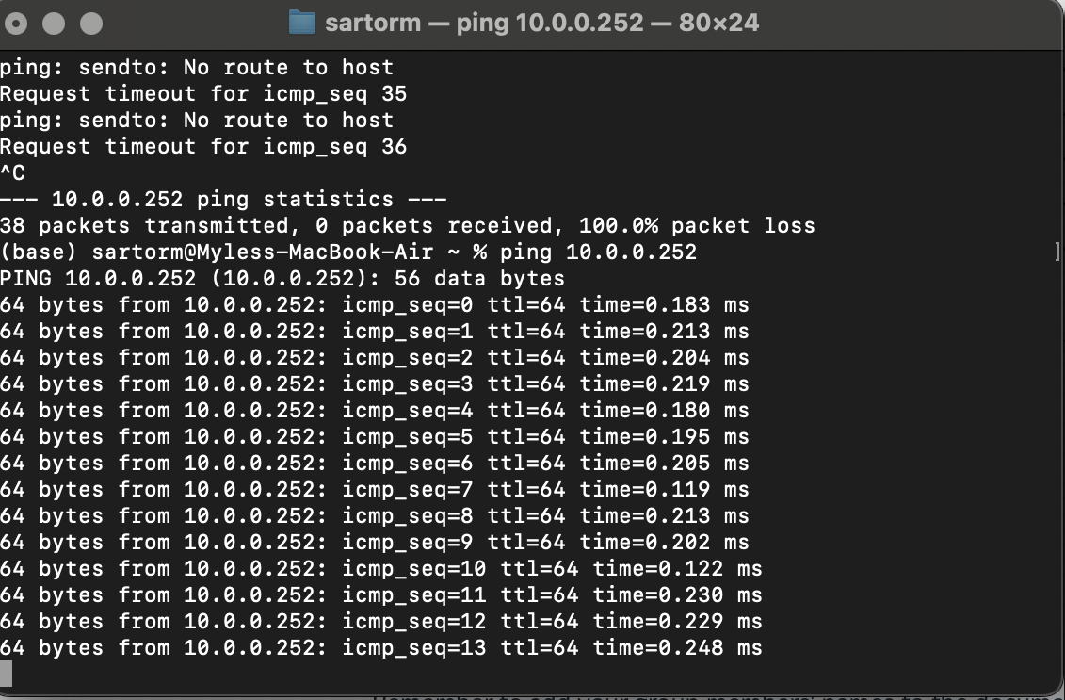
Partner’s IP address:
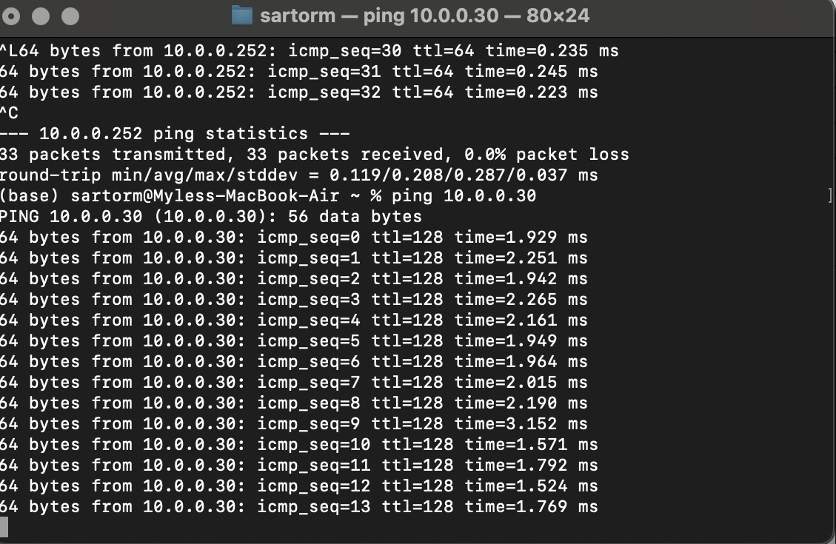

- Why does the diagram in Figure 1: Conceptual Model of Lab Network:
- have 2 stacks?

The diagram stacks represent two devices establishing a connection between one another along a network.

- have pieces of 4 Shannon diagrams, 2 of which are going "right to left" (posted upside down)?

One portion of the diagram moves right to left to display informative transmissions (download), and informative receiving (Upload). Furthermore, due to the setup being bi-directional, it goes the other way as well, representing the sending and receiving of information on both computers/devices.

- In our lab, what is physically the channel referred to in the diagrams?

The Cat6 ethernet cable refers to the channel that links the two devices with information together.

- Perform a brief I like, I wish, What if. review of this lab. (I like the... identifying what you like about the lab. I wish... share your thoughts on what could be improved. What if......propose new ideas or changes that could enhance the lab.)

I like that this lab was engaging and got us working with a new topic, networking that we were all somewhat familiar with. However, I wish we got to go more in-depth (Such as the importance of packets) with the usage of such information rather than just pinging the respective IP addresses and analyzing the data from them. What if we sent an abnormal amount of traffic or packet data/loss to one device, how would this affect its connection with the other?

- Round off your group activity by having each member contribute one unique question related to the lab.
Myles Sartor: To what extent can this procedure be utilized to troubleshoot real network problems?
Zachary Silver: How much faster can a wired connection between two computers share data compared to a wireless connection?
Taejeong Kim: Is using multiple ethernet connections faster than one wireless connection?
Sam Deung: Is the representation of network data consistent with real world norms?

